Web Design and Development

4COSC011W

Report

Author: K.A.D.S.T.Kumarapeli

Student ID: 2019952 / w1790958

Group Number: 02

Student Role: Student 04

<https://w1790958.users.ecs.westminster.ac.uk/student_01/presentaion-page.html>

1. Introduction 3

2. Technical Discussion 4

Site Map (SVG) 4

Gallery 8

Common features 19

3. Janet 22

References 23

Appendices 24

Appendix A: Code 24

File: Gallery 24

Index.html 24

Style.css 28

Script.js 31

File: Site Map 32

Index.html 32

style.css 36

script.js 37

Appendix B: Screenshots 38

Sitemap 38

gallery 39

Appendix C: Individual Statement 41

# Introduction

Among the given topics as group 2 we decided to create web page for travel agency and first of all we focused our page name and the logo logo was created by me using photoshop and exported svg , png formats. Page name is “HOLA” and logo created related to the topic and page theme.



Figure 1 : Logo

|  |  |  |  |  |
| --- | --- | --- | --- | --- |
| **Student roll** | **Student Name** | **IIT Number** | **UOW Number** | **Completed Tasks** |
| Student 01 | Janitha Ahangama | 2019910 | w1790898 | Presentation Page, Product Page, Student 01 Page editor age |
| Student 02 | Chathurangani Ranathunga | 2019923 | W1790948 | Main Page (Home Page), Feedback Page, Student 02 Page editor Page |
| Student 03 | Himaranga Miniruwan | 2019928 | W1909950 | Student Details Page,  Quiz Page,  Student 03 Page editor page |
| Student 04 | Saranga Thathsara | 2019952 | W1790958 | Gallery page, Sitemap Page, Student 04 Page editor page |

I am student 4 of this project. I had to create a Sitemap developed in SVG which will direct user to each part of the website. Then I had to create a Gallery which the user can view images and description of themselves. I created pull down menu to change background colour of the page and change text colour with the background colour of the gallery page.

# Technical Discussion

My roll is Student Number 04 in this coursework.

As a roll of Student 04, my task is to create a Gallery and Site Map using SVG of HOLA website. Between these two tasks my first task is Site Map

## Site Map (SVG)

Scalable Vector Graphics (SVG) is a vector graphic format, based on XML and is used to display a variety of graphics on the web and other environments. The student 4 had to design a Sitemap using SVG. It also had to direct links to each part of the website.

Index.html

<div class="site-map">

<svg width="100%" height="100%" stroke="null">

<g id="shapes">

<g id="home">

<rect rx="10" height="53" width="168" y="46" x="557" />

<text xml:space="preserve" text-anchor="start" id="homeTxt" y="82" x="598" fill-opacity="null"

stroke-opacity="null" stroke-width="0" stroke="#000000" fill="#b0553a">Home</text>

</g>

<g id="products">

<rect rx="10" height="53" width="168" y="184" x="56" />

<text xml:space="preserve" text-anchor="start" id="productsTxt" y="221" x="82" fill-opacity="null"

stroke-opacity="null" stroke-width="0" stroke="#000000" fill="#b0553a">Products</text>

</g>

<g id="quiz">

<rect rx="10" height="53" width="168" y="184" x="304" />

<text xml:space="preserve" text-anchor="start" id="quizTxt" y="221" x="353" fill-opacity="null"

stroke-opacity="null" stroke-width="0" stroke="#000000" fill="#b0553a">Quiz</text>

</g>

<g id="gallery">

<rect rx="10" height="53" width="168" y="184" x="823" />

<text xml:space="preserve" text-anchor="start" id="gallerryTxt" y="221" x="855" fill-opacity="null"

stroke-opacity="null" stroke-width="0" stroke="#000000" fill="#b0553a">Gallery</text>

</g>

<g id="aboutUs">

<rect rx="10" height="53" width="168" y="184" x="1066" />

<text xml:space="preserve" text-anchor="start" id="aboutUsTxt" y="221" x="1097" fill-opacity="null"

stroke-opacity="null" stroke-width="0" stroke="#000000" fill="#b0553a">AboutUs</text>

</g>

<g id="feedback">

<rect rx="10" height="53" width="168" y="395" x="1198" />

<text xml:space="preserve" text-anchor="start" id="contactUsTxt" y="430" x="1216"

fill-opacity="null" stroke-opacity="null" stroke-width="0" stroke="#000000"

fill="#b0553a">ContactUs</text>

</g>

<g id="team">

<rect rx="10" height="53" width="168" y="315" x="1198" />

<text xml:space="preserve" text-anchor="start" id="ourTeamTxt" y="352" x="1220" fill-opacity="null"

stroke-opacity="null" stroke-width="0" stroke="#000000" fill="#b0553a">Our Team</text>

</g>

</g>

<g id="site-map-lines">

<line id="homeLine" y2="145" x2="640" y1="100" x1="640" />

<line stroke-linecap="null" stroke-linejoin="null" id="mainLine" y2="145" x2="1151" y1="144" x1="140" />

<line stroke-linecap="null" stroke-linejoin="null" id="productsLine" y2="184" x2="140" y1="144"

x1="140" />

<line stroke-linecap="null" stroke-linejoin="null" id="quizLline" y2="185" x2="388" y1="145" x1="387" />

<line stroke-linecap="null" stroke-linejoin="null" id="aboutUsMainLine1" y2="184." x2="1149" y1="144"

x1="1149" />

<line stroke-linecap="null" stroke-linejoin="null" id="galleryLine" y2="185" x2="906" y1="145"

x1="906" />

<line stroke-linecap="null" stroke-linejoin="null" id="aboutUsMainLine2" y2="423" x2="1149" y1="239"

x1="1149" />

<line stroke-linecap="null" stroke-linejoin="null" id="teamLine" y2="343" x2="1198" y1="342"

x1="1149" />

<line stroke-linecap="null" stroke-linejoin="null" id="contactUsLine" y2="422" x2="1198" y1="422"

x1="1149" />

</g>

</svg>

</div>

Above page used SVG elements to give recommended web structure.

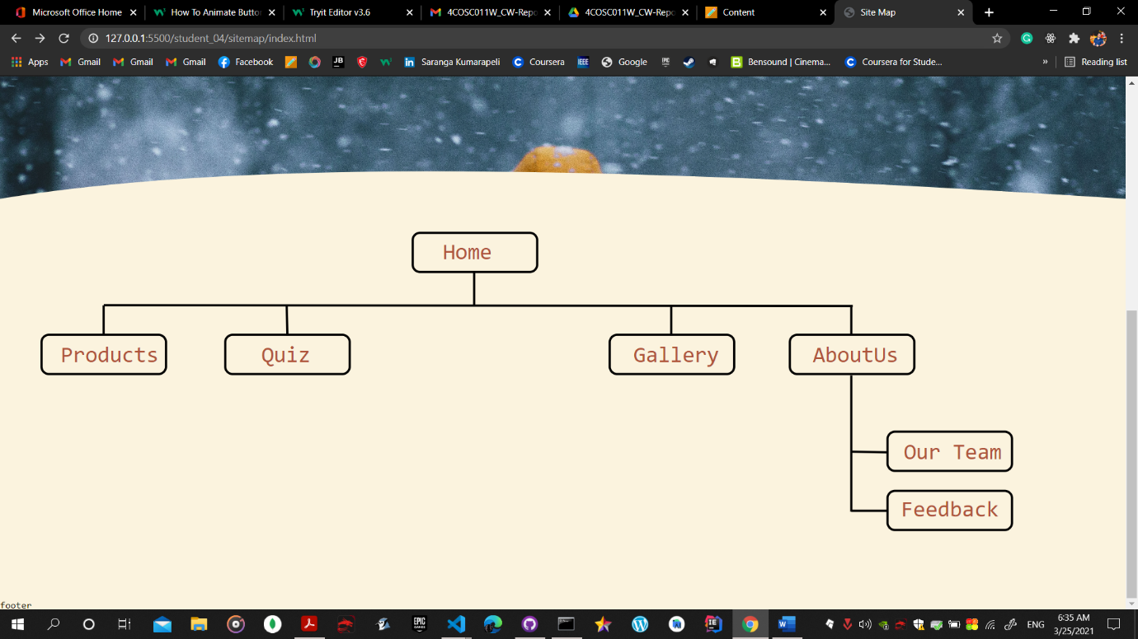

Figure 2: site map

I used hover effect to all squere shapes in svg, first grouped and gave id to each square and in css file added hover and added some attributes to change text weight and change square fill colour.

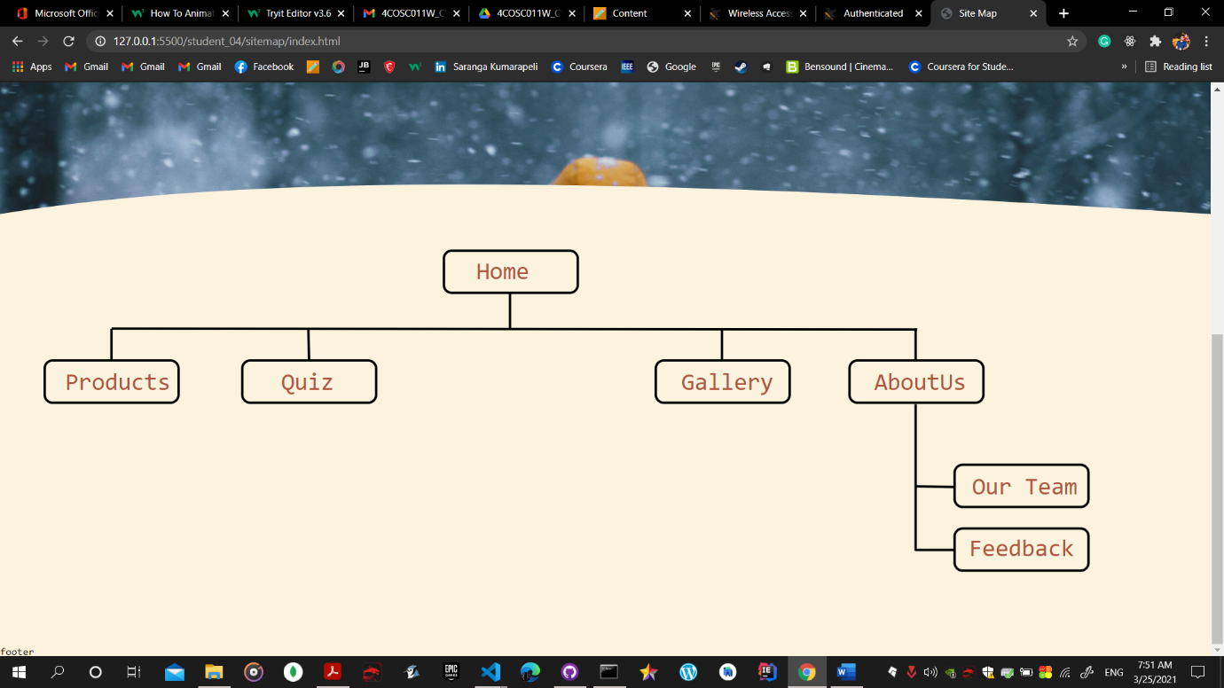

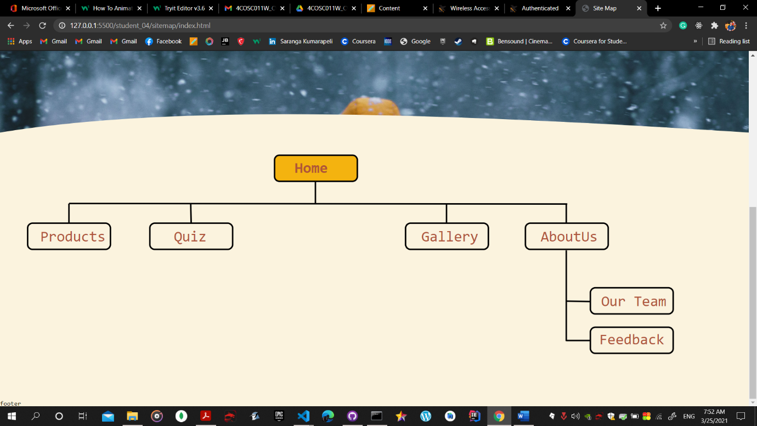

Linked all pages to the site map and just one click user will be able to access all pages relevant to our web site. Used java script to connect all pages to the relevant scg squares.

*//site map linking all pages*

document.getElementById("home").addEventListener("click", () => {

    document.location.href = "../../student_02/html_files/student_02_main.html";

});

document.getElementById("products").addEventListener("click", () => {

    document.location.href = "../../student_01/products.html";

});

document.getElementById("quiz").addEventListener("click", () => {

    document.location.href = "../../Student_03/html_files/quiz.html";

});

document.getElementById("gallery").addEventListener("click", () => {

    document.location.href = "../gallery/index.html";

});

document.getElementById("feedback").addEventListener("click", () => {

    document.location.href = "../../student_02/html_files/feedback.html";

});

document.getElementById("team").addEventListener("click", () => {

    document.location.href = "../../Student_03/html_files/student_details.html";

});

In get the relevant svg by id and when It clicked linked document will be displayed to the user.

## Gallery

For the gallery first I searched royalty free images. And added common cover div to get uniqueness to my pages. There are 8 images and when mouse pointer on top of one it will popup with animation, I used css for that part and when user clicks one of image it will displays in below area used some javascript for than functional activity

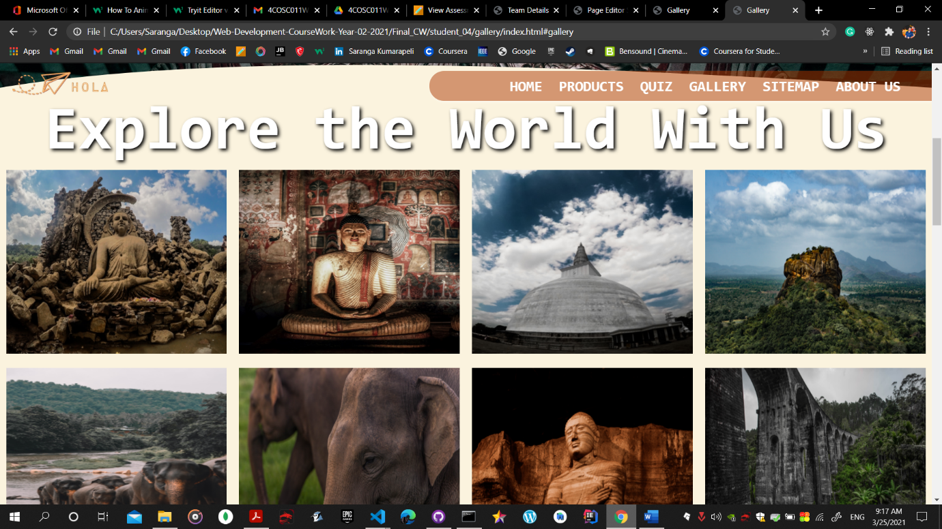

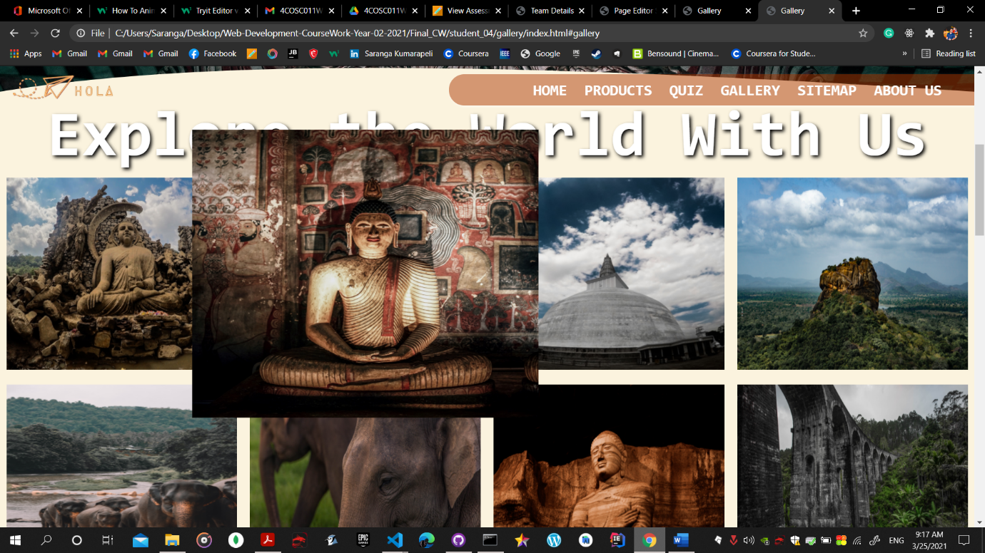

.column img {

    cursor: pointer;

    width: 250px;

    height: 300px;

}

.column img:hover {

    transform: scale(1.5);

}

.column img {

    transition: transform 0.5s;

}

When user in gallery page and click gallery from navigation bar it will slowly travel to gallery content area

For archive that used simple html and css line of codes.

In nav bar linked to gallery content id

 <li><a class="link" href="#gallery">Gallery</a></li>

Css

html {

    scroll-behavior: smooth;

}

When click on image:

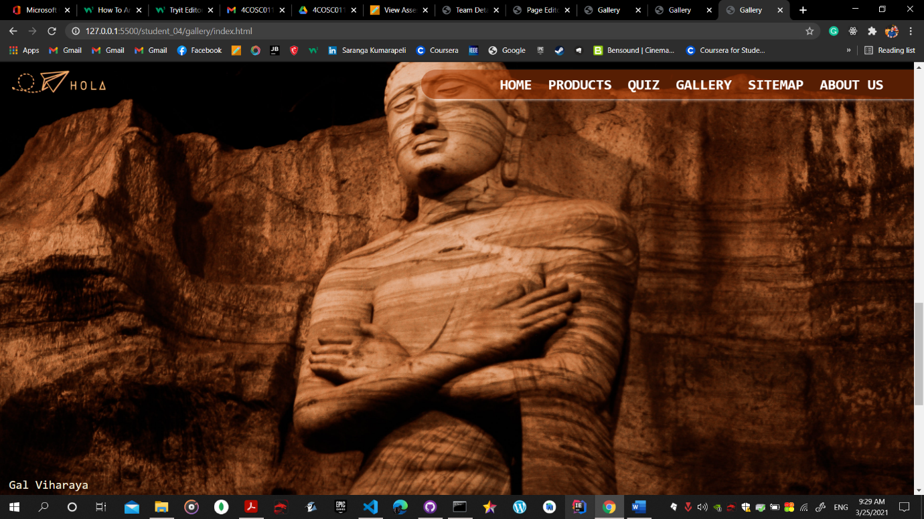

Html part for above activity

<div id="gallery" style="margin-bottom: 100px;">

        <div class="row">

            <div class="column">

                <img src="./assets/images/image1.jpg" alt="Lo Viharaya       This is mock text - Lorem ipsum dolor sit amet consectetur adipisicing elit. Minima ipsam necessitatibus ducimus eum minus nesciunt ea dicta ut fugit quisquam ad alias, soluta incidunt, nemo delectus nostrum. Ab dolorem amet, vel, culpa sequi eaque perspiciatis quos velit molestiae excepturi ducimus? Quas suscipit rem facere ad, soluta animi. Maiores, amet quod?"

                    style="width:100%" onclick="myFunction(this);">

            </div>

            <div class="column">

                <img src="./assets/images/image2.jpg" alt="Dhambulu Viharaya" style="width:100%" onclick="changeImages(this);">

            </div>

            <div class="column">

                <img src="./assets/images/image3.jpg" alt="TThuuparamaya" style="width:100%" onclick="changeImages(this);">

            </div>

            <div class="column">

                <img src="./assets/images/image4.jpg" alt="Sigiriya" style="width:100%" onclick="changeImages(this);">

            </div>

            <div class="column">

                <img src="./assets/images/image5.jpg" alt="Pinnawala" style="width:100%" onclick="changeImages(this);">

            </div>

            <div class="column">

                <img src="./assets/images/image6.jpg" alt="Elephant - mock text" style="width:100%" onclick="changeImages(this);">

            </div>

            <div class="column">

                <img src="./assets/images/image7.jpg" alt="Gal Viharaya" style="width:100%" onclick="changeImages(this);">

            </div>

            <div class="column">

                <img src="./assets/images/image8.jpg" alt="Nine Arches Bridge" style="width:100%" onclick="changeImages(this);">

            </div>

        </div>

        <div class="container">

            <span onclick="this.parentElement.style.display='none'" class="closebtn">&times;</span>

            <img id="expandedImg" style="width:100%">

            <div id="imgtext"></div>

        </div>

Js part

function changeImages(*imgs*) {

    var expandImg = document.getElementById("expandedImg");

    var imgText = document.getElementById("imgtext");

    expandImg.src = *imgs*.src;

    imgText.innerHTML = *imgs*.alt;

    expandImg.parentElement.style.display = "block";

}

In gallery user will be able to change the background colour

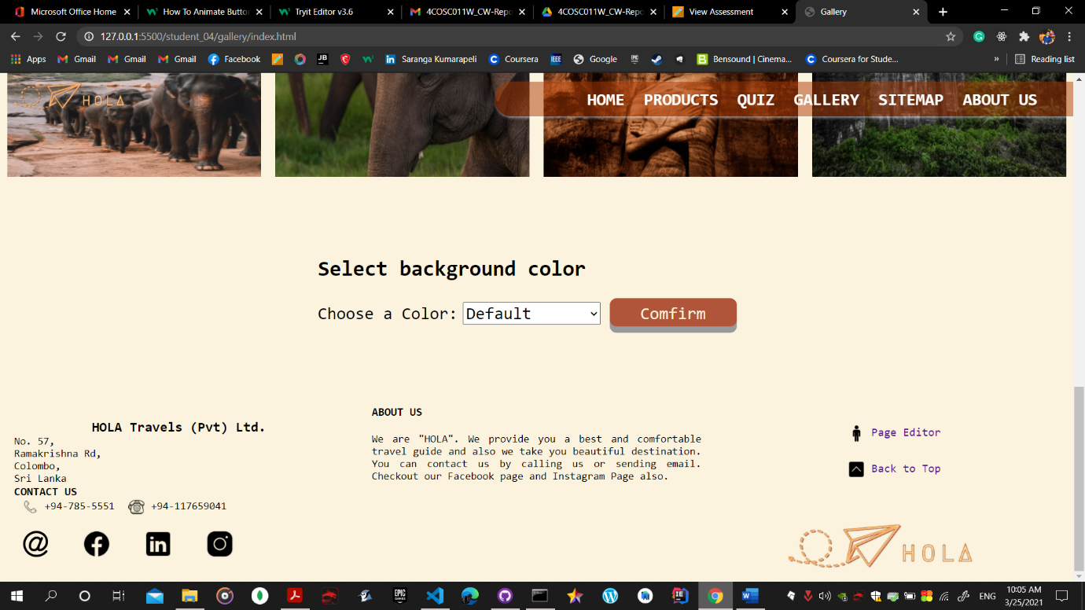

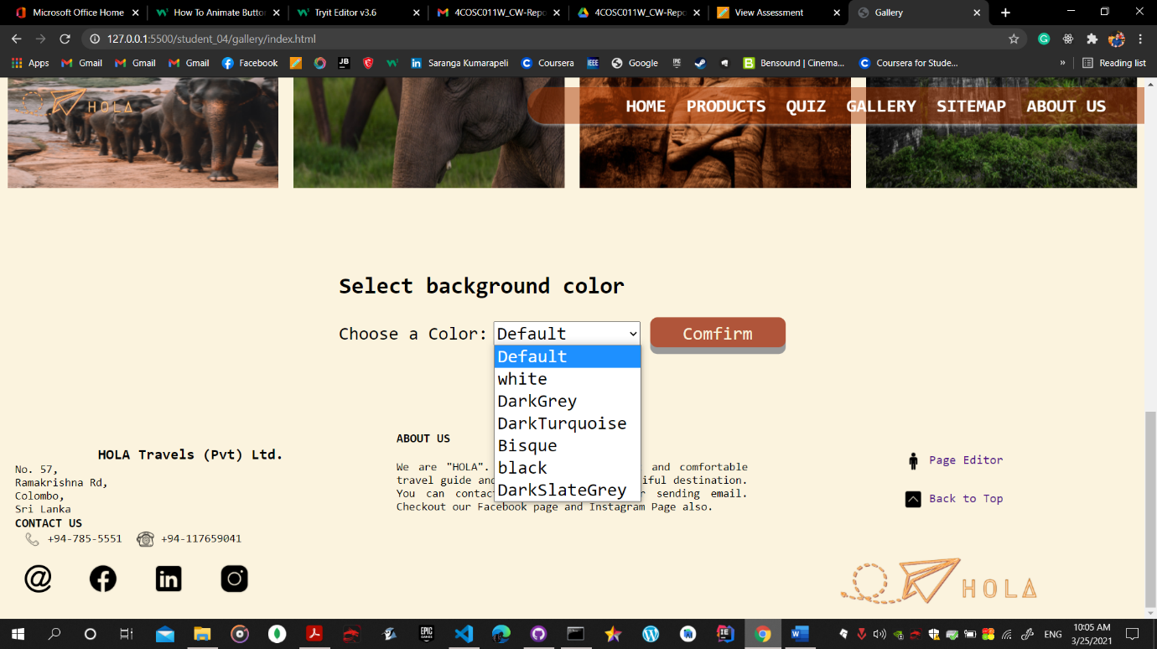

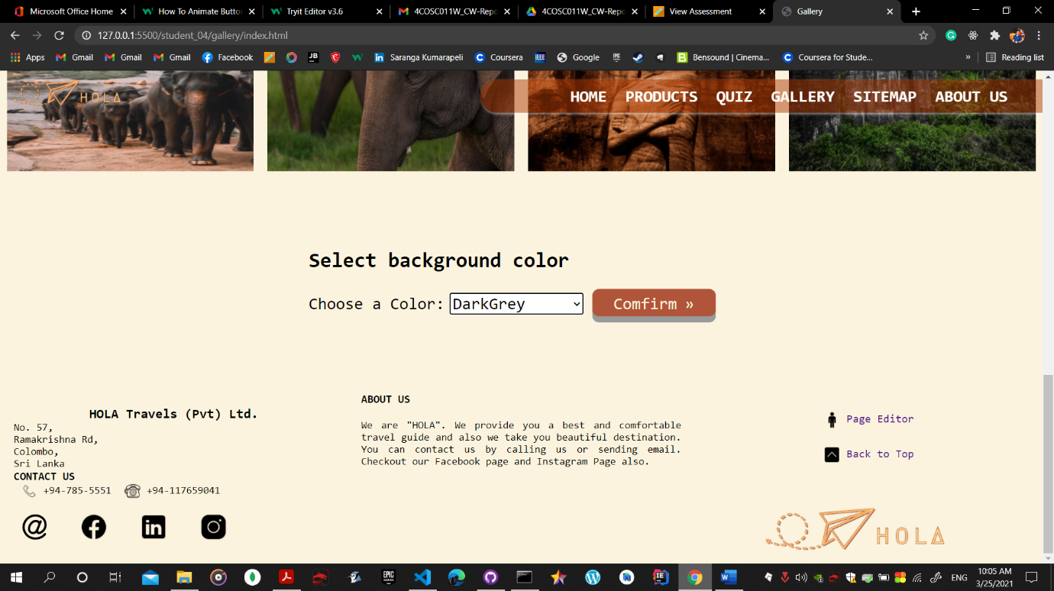

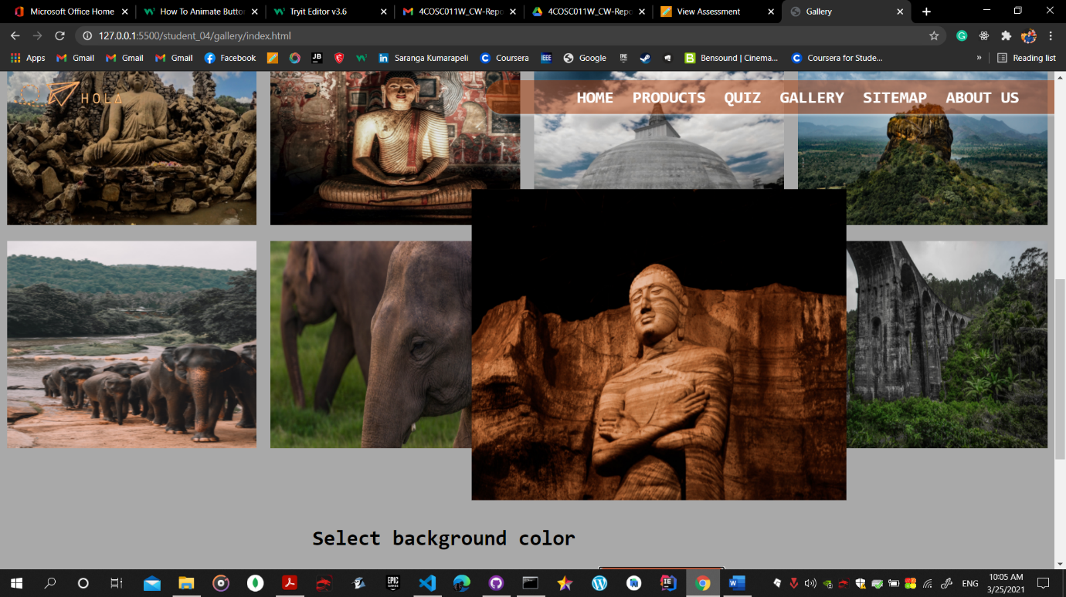

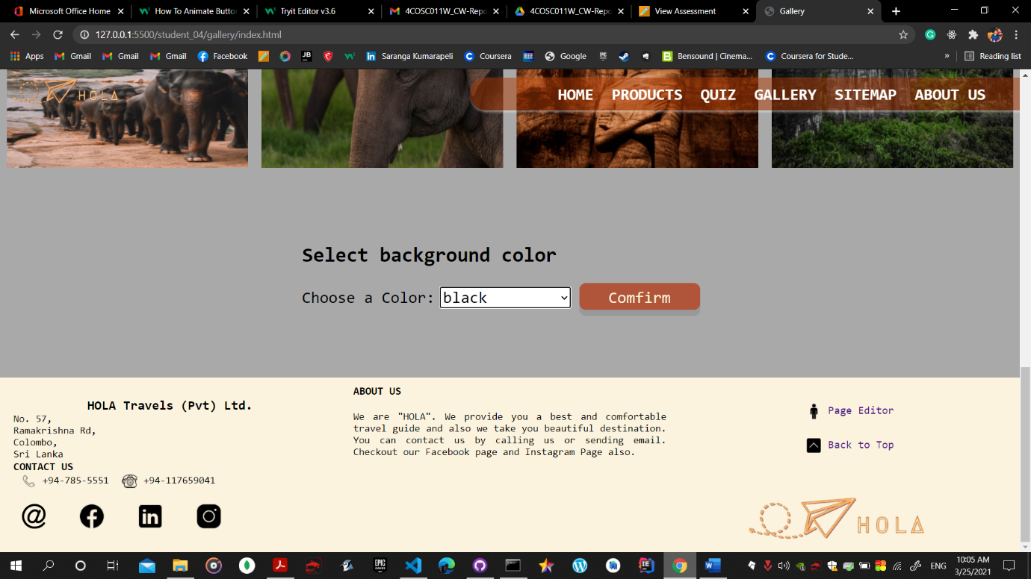

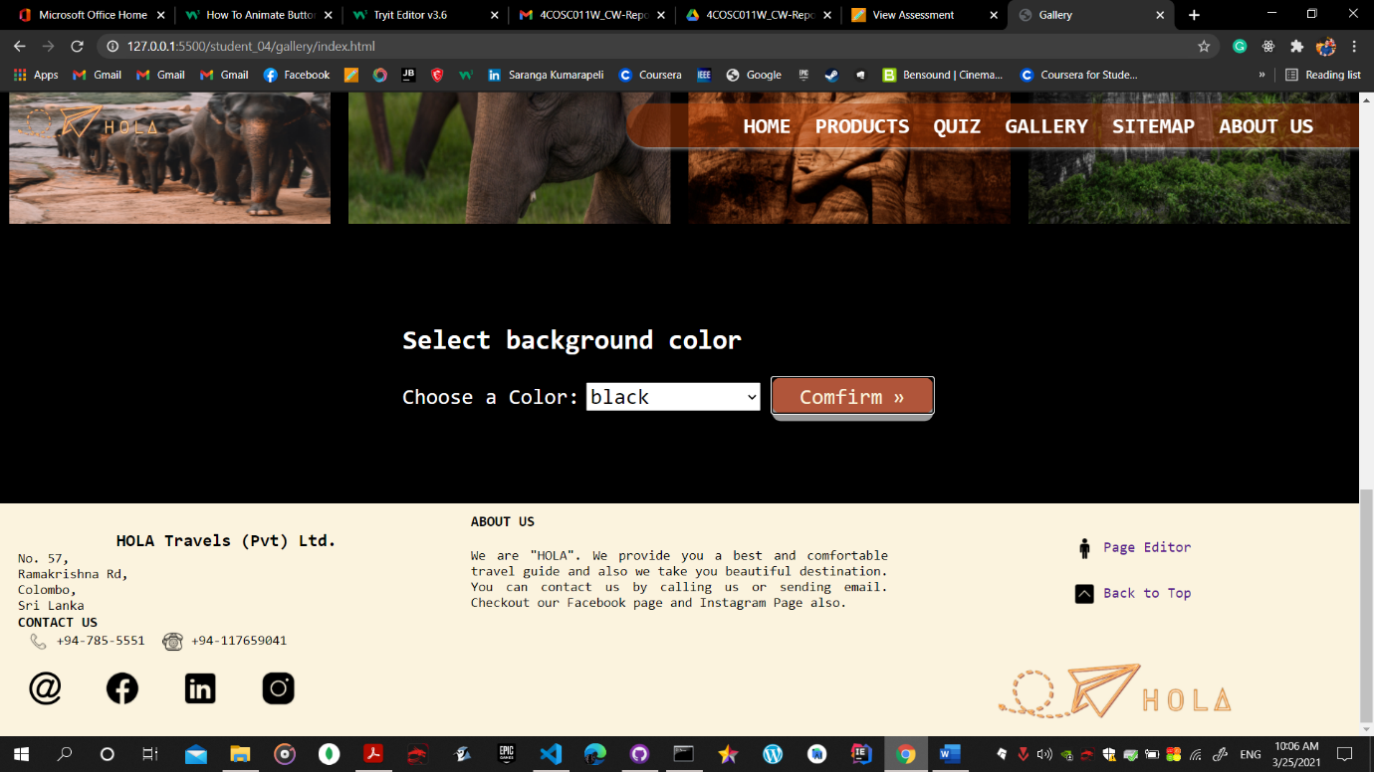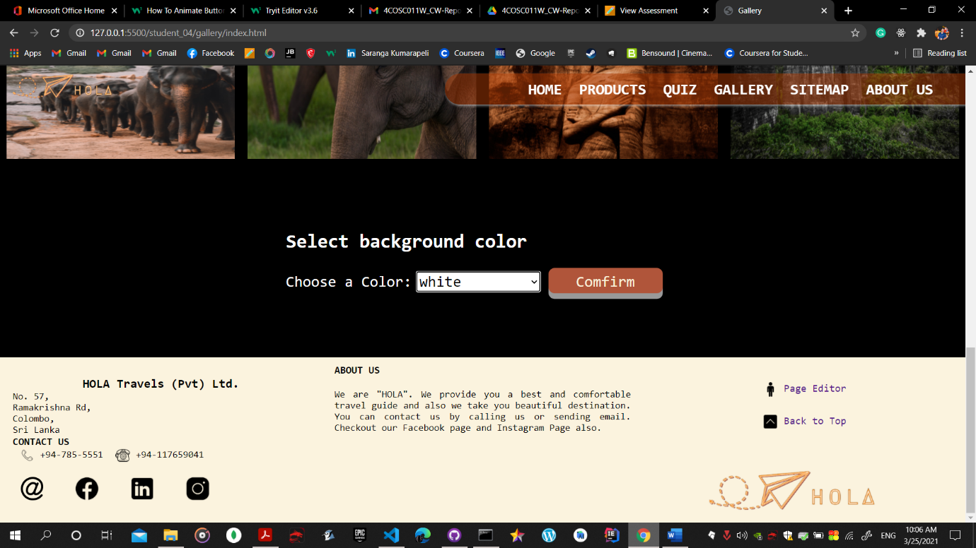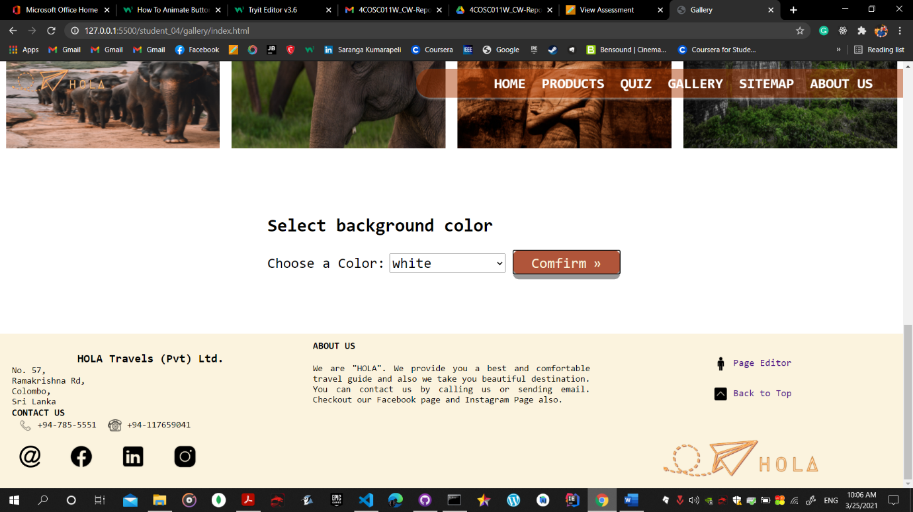

According to dark background colours text will changed to white and I used some if conditions to filter which colour selected by the user and according to the selection colour will change.

Used jsvascript for archive that

function backgroundColour() {

    var selectedColor = document.getElementById("selectId");

    var text = document.getElementById("paraText");

    var paraText = document.getElementById("choseColor");

    var bgColor = selectedColor.options[selectedColor.selectedIndex].value;

    document.body.style.backgroundColor = bgColor;

    if (bgColor == "black" || bgColor == "DarkSlateGrey") {

        text.style.color = "white";

        paraText.style.color = "white";

    }

    if (bgColor == "Bisque" || bgColor == "white") {

        text.style.color = "black";

        paraText.style.color = "black";

    }

    if (bgColor == "Default") {

        document.body.style.backgroundColor = "rgb(251, 243, 222)";

        text.style.color = "black";

        paraText.style.color = "black";

    }

}

Here the html code for that function

<form id="bgColorChange" style="height:100px">

        <p id="paraText"><b>Select background color</b></p>

        <label id="choseColor" for="colors">Choose a Color:</label>

        <select id="selectId">

            <option class="default">Default</option>

            <option class="white">white</option>

            <option class="DarkGrey">DarkGrey</option>

            <option class="DarkTurquoise">DarkTurquoise</option>

            <option class="bisque">Bisque</option>

            <option class="black">black</option>

            <option class="DarkSlateGrey">DarkSlateGrey</option>

        </select>

        <button class="button" type="button" onclick="backgroundColour()"><span>Comfirm </span></button>

    </form>

Added hover effect to the confirm button in gallery page.

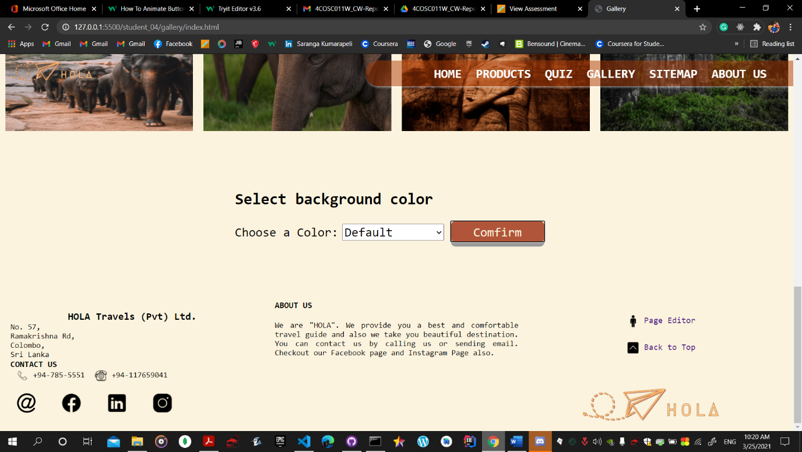

When mouse on top of the button



I used html and css for this

<button class="button" type="button" onclick="backgroundColour()"><span>Comfirm </span></button>

Css

.button {

    border-radius: 10px;

    background-color: #b0553a;

    border: none;

    color: #fbf3de;

    text-align: center;

    font-size: 24px;

    padding: 7px;

    width: 180px;

    height: 40px;

    transition: all 0.5s;

    cursor: pointer;

    margin: 5px;

    box-shadow: 0 9px #999;

}

.button span {

    cursor: pointer;

    display: inline-block;

    position: relative;

    transition: 0.5s;

}

.button span:after {

    content: "\00bb";

    position: absolute;

    opacity: 0;

    top: 0;

    right: -20px;

    transition: 0.5s;

}

.button:hover span {

    padding-right: 25px;

}

.button:hover span:after {

    opacity: 1;

    right: 0;

}

## Common features

For my all pages I used Fixed cover photo to get unique UI and improve attractiveness in my pages

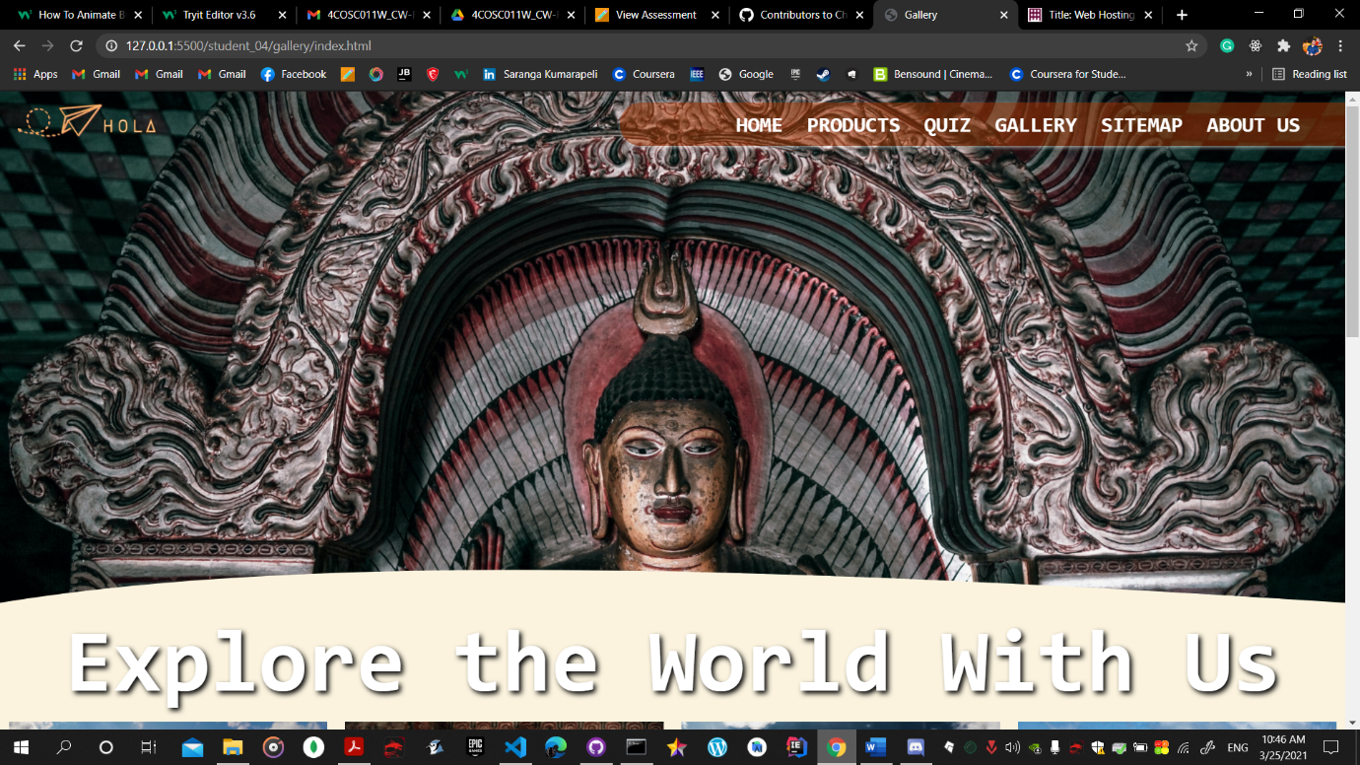

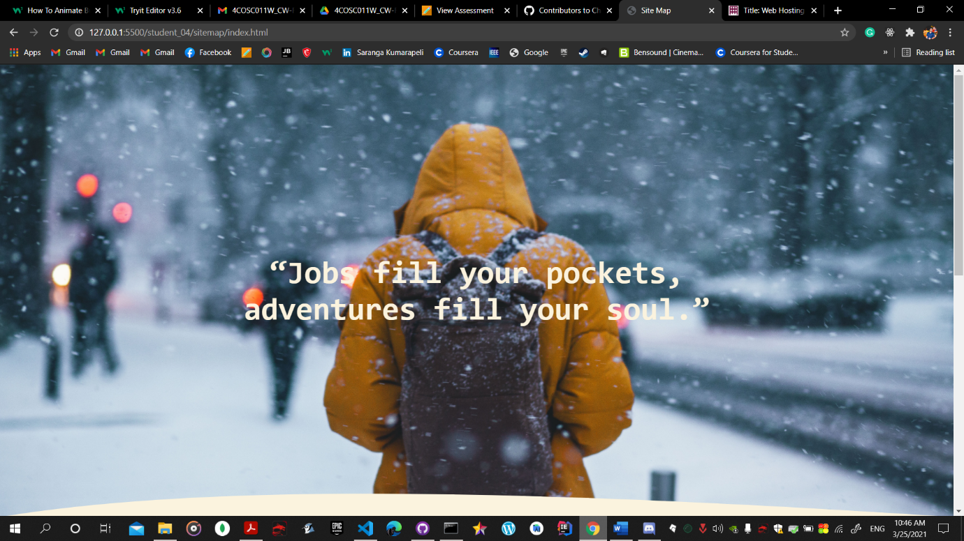

Used common css codes for both css files

.cover {

    background: #000000 center/cover url(*../gallery/assets/images/cover.jpg*);

    text-align: center;

    position: relative;

    height: 80vh;

    background-attachment: fixed;

    background-position: center;

    background-repeat: no-repeat;

    background-size: cover;

}

Used common svg curve shape in both pages and got some UI design for my pages

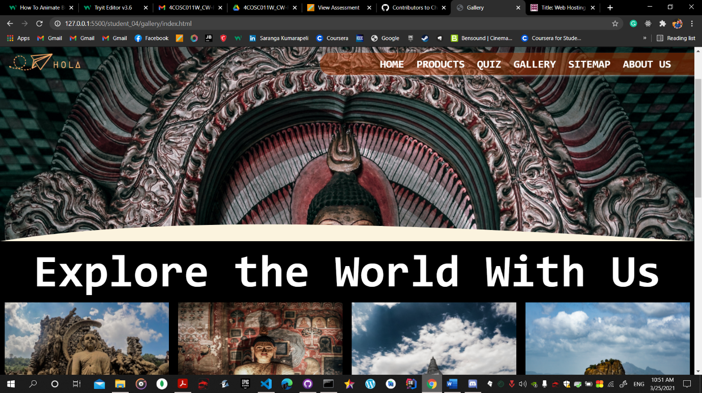

 <svg class="curveUpSvg" version="1.1" width="100%" height="100" viewBox="0 0 100 100" preserveAspectRatio="none">

            <path d="M0 100 C 20 0 50 0 100 100 Z" />

        </svg>

Css for that

.curveUpSvg {

    fill: #fbf3de;

    height: 50px;

    width: 100%;

    position: absolute;

    bottom: 0;

    left: 0;

}

For the page editor pages all of us used same format to maintain website’s UI standard and changed same html file according to each member

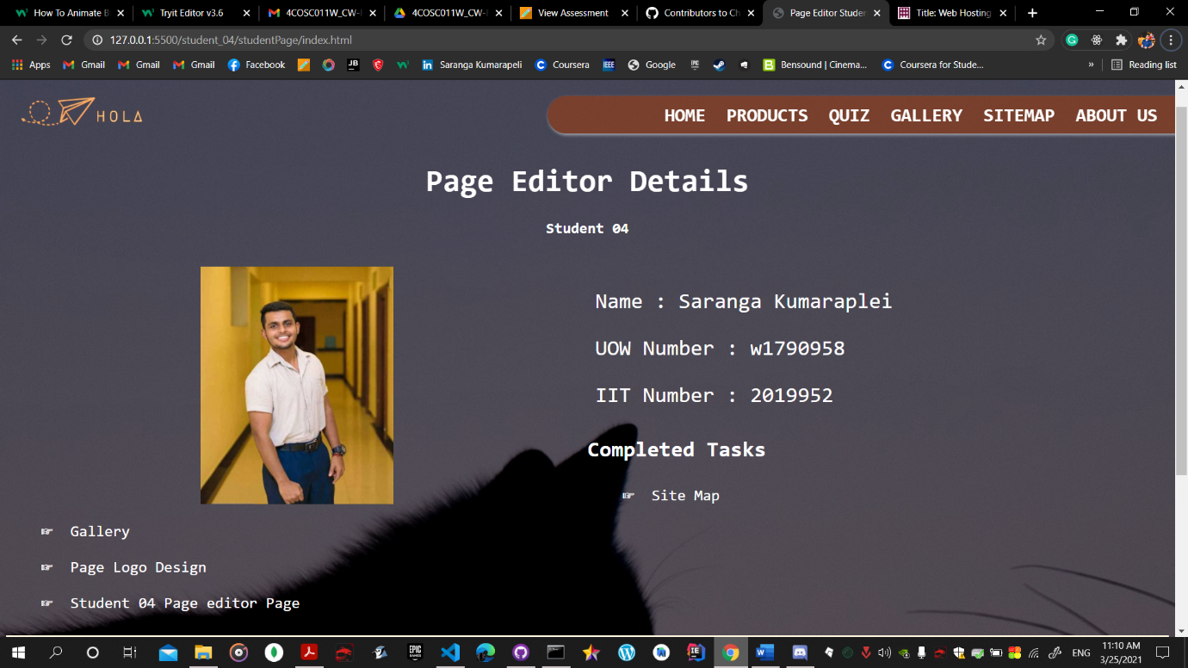

# Janet

According to the janet regulations I mostly considered about copyrights because I had to create gallery for the website. I used eight photos for gallery page and used royalty free images from famous website among web developers. Used all icons and BG images from royalty free sites.

When creating the logo I used photoshop for the creation and exported it into png files and svg files to our use. That’s how we considered about janet regulations. Those all actions will avoided copyright issues in HOLA website.

As the distributed version control system we used Git Hub to collaborate among group members with our whole work time and Discord for the communication.

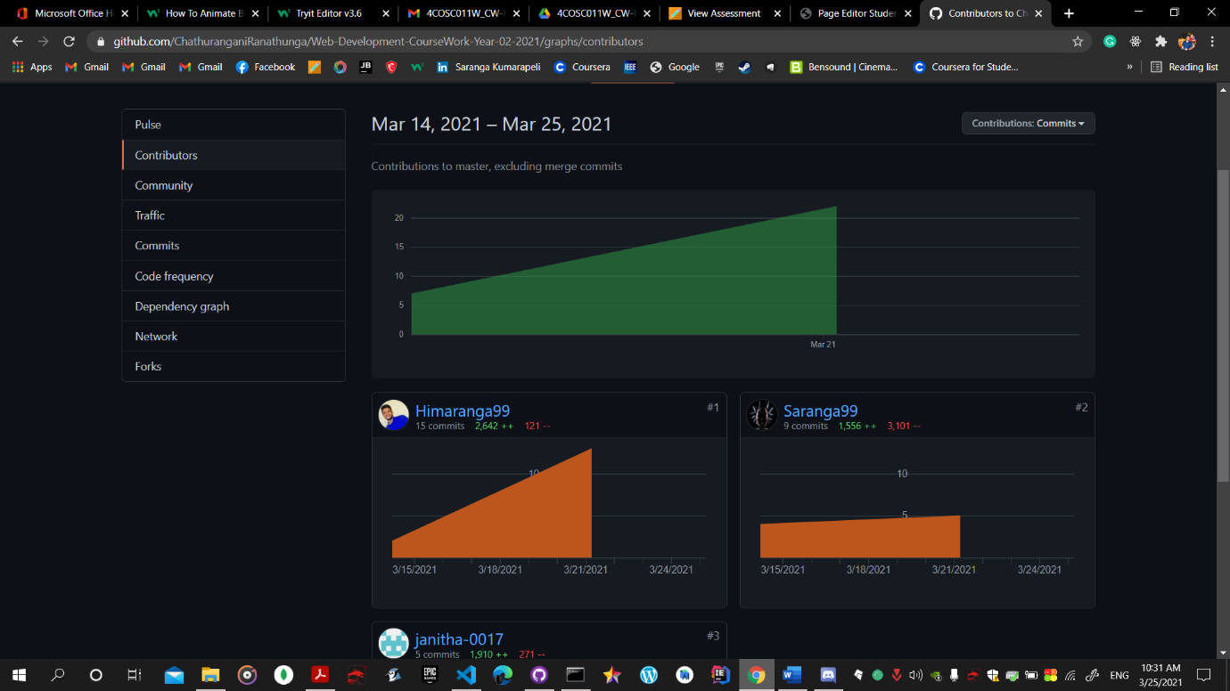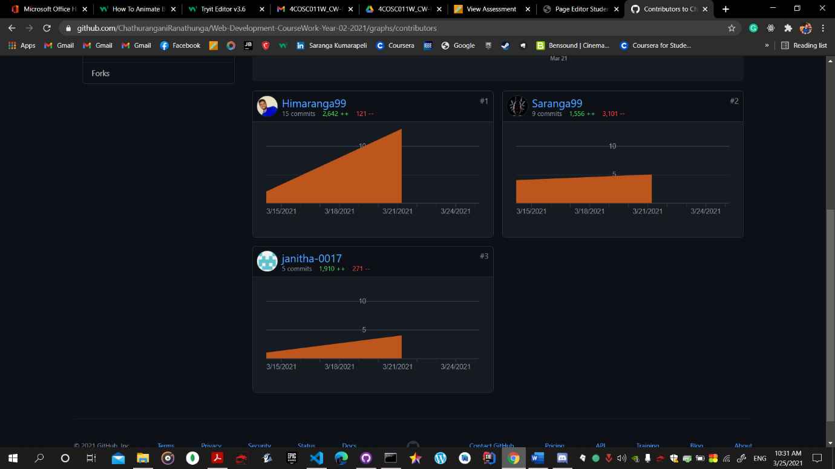

# References

• Stack over flow (2021). Stack Overflow - <https://stackoverflow.com/>

• HTML, CSS.(2021) W3Schools - <https://www.w3schools.com/>

• Free Background images Unsplash website - <https://unsplash.com/>

# Appendices

## Appendix A: Code

## File: Gallery

### Index.html

<!DOCTYPE html>

<html lang="en">

<head>

<meta charset="UTF-8">

<link rel="stylesheet" href="./style.css" />

<link href="../../public_css/navbar.css" rel="stylesheet">

<title>Gallery</title>

</head>

<body>

<div class="header" id="top">

<div class="navbar">

<div class="logoHola">

<img src="../assets/logo/3.png">

</div>

<ul>

<li><a class="link" href="../../student_02/html_files/student_02_main.html">Home</a></li>

<li><a class="link" href="../../student_01/products.html">Products</a></li>

<li><a class="link" href="../../Student_03/html_files/quiz.html">Quiz</a></li>

<li><a class="link" href="#gallery">Gallery</a></li>

<li><a class="link" href="../sitemap/index.html">SiteMap</a></li>

<li><a class="link" href="#">About US</a>

<div class="sub-menu">

<ul class="sub-ul">

<li class="li"><a href="../../Student_03/html_files/student_details.html" class="a">Team</a>

</li>

<li class="li"><a href="../../student_02/html_files/feedback.html" class="a">feedback</a>

</li>

</ul>

</div>

</li>

</ul>

</div>

</div>

<div class="cover" height="356">

<svg class="curveUpSvg" version="1.1" width="100%" height="100" viewBox="0 0 100 100" preserveAspectRatio="none">

<path d="M0 100 C 20 0 50 0 100 100 Z" />

</svg>

</div>

<h1 id="quote">Explore the World With Us</h1>

<div id="gallery" style="margin-bottom: 100px;">

<div class="row">

<div class="column">

<img src="./assets/images/image1.jpg" alt="Lo Viharaya This is mock text - Lorem ipsum dolor sit amet consectetur adipisicing elit. Minima ipsam necessitatibus ducimus eum minus nesciunt ea dicta ut fugit quisquam ad alias, soluta incidunt, nemo delectus nostrum. Ab dolorem amet, vel, culpa sequi eaque perspiciatis quos velit molestiae excepturi ducimus? Quas suscipit rem facere ad, soluta animi. Maiores, amet quod?"

style="width:100%" onclick="myFunction(this);">

</div>

<div class="column">

<img src="./assets/images/image2.jpg" alt="Dhambulu Viharaya" style="width:100%" onclick="changeImages(this);">

</div>

<div class="column">

<img src="./assets/images/image3.jpg" alt="TThuuparamaya" style="width:100%" onclick="changeImages(this);">

</div>

<div class="column">

<img src="./assets/images/image4.jpg" alt="Sigiriya" style="width:100%" onclick="changeImages(this);">

</div>

<div class="column">

<img src="./assets/images/image5.jpg" alt="Pinnawala" style="width:100%" onclick="changeImages(this);">

</div>

<div class="column">

<img src="./assets/images/image6.jpg" alt="Elephant - mock text" style="width:100%" onclick="changeImages(this);">

</div>

<div class="column">

<img src="./assets/images/image7.jpg" alt="Gal Viharaya" style="width:100%" onclick="changeImages(this);">

</div>

<div class="column">

<img src="./assets/images/image8.jpg" alt="Nine Arches Bridge" style="width:100%" onclick="changeImages(this);">

</div>

</div>

<div class="container">

<span onclick="this.parentElement.style.display='none'" class="closebtn">&times;</span>

<img id="expandedImg" style="width:100%">

<div id="imgtext"></div>

</div>

</div>

<form id="bgColorChange" style="height:100px">

<p id="paraText"><b>Select background color</b></p>

<label id="choseColor" for="colors">Choose a Color:</label>

<select id="selectId">

<option class="default">Default</option>

<option class="white">white</option>

<option class="DarkGrey">DarkGrey</option>

<option class="DarkTurquoise">DarkTurquoise</option>

<option class="bisque">Bisque</option>

<option class="black">black</option>

<option class="DarkSlateGrey">DarkSlateGrey</option>

</select>

<button class="button" type="button" onclick="backgroundColour()"><span>Comfirm </span></button>

</form>

<footer>

<div class="footer">

<div class="footer-left box">

<div class="footer-content">

<div id="footer-logo">

</div>

<div class="footer-details">

<h2>HOLA Travels (Pvt) Ltd.</h2>

<div id="address">

<p>No. 57,<br> Ramakrishna Rd,<br>Colombo,<br>Sri Lanka</p>

</div>

<div class="contact">

<h1>Contact Us</h1>

<div id="mobile">

<p>

<img src="../../public_img/mobile.png" alt="mobile-icon" class="footer-icon"> +94-785-5551

<img src="../../public_img/phone.png" alt="phone-icon" class="footer-icon"> +94-117659041

</p>

</div>

<div class="footer-social">

<a href=https://mail.google.com/mail/?view=cm&fs=1&tf=1&to=holatravels.info@gmail.com target="_blank">

<img src="../../public_img/footer-email.png" alt="email-image" class="footer-social-icon">

</a>

<a href="https://www.facebook.com/iitsl" target="_blank">

<img src="../../public_img/footer-facebook.png" alt="facebook-image" class="footer-social-icon">

</a>

<a href="https://www.linkedin.com/company/informatics-institute-of-technology/" target="_blank">

<img src="../../public_img/footer-linkedin.png" alt="linkedin-image" class="footer-social-icon">

</a>

<a href="https://instagram.com/iitlife?igshid=rc07mrrpmfw6" target="_blank">

<img src="../../public_img/footer-instagram.png" alt="email-image" class="footer-social-icon">

</a>

</div>

</div>

</div>

</div>

</div>

<div class="footer-center box">

<h1>About Us</h1>

<div class="footer-content">

<p>We are "HOLA". We provide you a best and comfortable travel guide and also we take you beautiful destination. You can contact us by calling us or sending email. Checkout our Facebook page and Instagram Page also.</p>

</div>

</div>

<div class="footer-right box">

<div class="footer-content">

<ul>

<li>

<a href="../studentPage/index.html" id="page-editor"><img src="../../public_img/page-editor-logo.png" alt="page-editor-logo" class="footer-control-icon">Page Editor</a>

</li>

<li>

<a href="#top" id="back-to-top"><img src="../../public_img/back-to-top.png" alt="back-to-top-Icon" class="footer-control-icon">Back to Top</a>

</li>

</ul>

<div class="footer-logo">

<img src="../../public_img/LogoH.png" alt="logo" id="footer-logo-image">

</div>

</div>

</div>

</div>

</footer>

<script src="./script.js"></script>

</body>

</html>

### Style.css

* {

padding: 0;

margin: 0;

font-family: monospace;

}

html {

scroll-behavior: smooth;

}

body {

background-color: #fbf3de;

}

.cover {

background: #000000 center/cover url(../gallery/assets/images/cover.jpg);

text-align: center;

position: relative;

height: 80vh;

background-attachment: fixed;

background-position: center;

background-repeat: no-repeat;

background-size: cover;

}

.curveUpSvg {

fill: #fbf3de;

height: 50px;

width: 100%;

position: absolute;

bottom: 0;

left: 0;

}

#quote {

text-align: center;

font-size: 100px;

margin-top: 7px;

color: white;

text-shadow: 3px 3px 6px #000000;

}

* {

box-sizing: border-box;

}

body {

margin: 0;

font-family: Arial;

}

/* gallery */

.column {

float: left;

width: 25%;

padding: 10px;

}

/* popup */

.column img {

cursor: pointer;

width: 250px;

height: 300px;

}

.column img:hover {

transform: scale(1.5);

}

.column img {

transition: transform 0.5s;

}

/* Clear floats after the columns */

.row:after {

content: "";

display: table;

clear: both;

}

/* The expanding image container */

.container {

position: relative;

display: none;

}

/* Expanding image text */

#imgtext {

position: absolute;

bottom: 15px;

left: 15px;

color: #fbf3de;

font-size: 20px;

}

/* Closable button inside the expanded image */

.closebtn {

position: absolute;

top: 10px;

right: 15px;

color: #fbf3de;

font-size: 35px;

cursor: pointer;

}

.button {

border-radius: 10px;

background-color: #b0553a;

border: none;

color: #fbf3de;

text-align: center;

font-size: 24px;

padding: 7px;

width: 180px;

height: 40px;

transition: all 0.5s;

cursor: pointer;

margin: 5px;

box-shadow: 0 9px #999;

}

.button span {

cursor: pointer;

display: inline-block;

position: relative;

transition: 0.5s;

}

.button span:after {

content: "\00bb";

position: absolute;

opacity: 0;

top: 0;

right: -20px;

transition: 0.5s;

}

.button:hover span {

padding-right: 25px;

}

.button:hover span:after {

opacity: 1;

right: 0;

}

#paraText {

font-size: 30px;

font-weight: 800;

margin-bottom: 20px;

}

#choseColor {

font-size: 24px;

border-radius: 20px;

}

#selectId {

font-size: 24px;

}

#bgColorChange {

margin: 100px 450px;

}

### Script.js

function changeImages(imgs) {

var expandImg = document.getElementById("expandedImg");

var imgText = document.getElementById("imgtext");

expandImg.src = imgs.src;

imgText.innerHTML = imgs.alt;

expandImg.parentElement.style.display = "block";

}

function backgroundColour() {

var selectedColor = document.getElementById("selectId");

var text = document.getElementById("paraText");

var paraText = document.getElementById("choseColor");

var bgColor = selectedColor.options[selectedColor.selectedIndex].value;

document.body.style.backgroundColor = bgColor;

if (bgColor == "black" || bgColor == "DarkSlateGrey") {

text.style.color = "white";

paraText.style.color = "white";

}

if (bgColor == "Bisque" || bgColor == "white") {

text.style.color = "black";

paraText.style.color = "black";

}

if (bgColor == "Default") {

document.body.style.backgroundColor = "rgb(251, 243, 222)";

text.style.color = "black";

paraText.style.color = "black";

}

}

## File: Site Map

### Index.html

<!DOCTYPE html>

<html lang="en">

<head>

<meta charset="UTF-8">

<link rel="stylesheet" href="./style.css" />

<link rel="stylesheet" href="../../public_css/navbar.css" />

<title>Site Map</title>

</head>

<body>

<div class="cover">

<h1 class="quote">“Jobs fill your pockets, adventures fill your soul.”</h1>

<svg class="curveUpSvg" xmlns="http://www.w3.org/2000/svg" version="1.1" width="100%" height="100" viewBox="0 0 100 100" preserveAspectRatio="none">

<path d="M0 100 C 20 0 50 0 100 100 Z" />

</svg>

</div>

<div class="site-map">

<svg width="100%" height="100%" stroke="null">

<g id="shapes">

<g id="home">

<rect rx="10" height="53" width="168" y="46" x="557" />

<text xml:space="preserve" text-anchor="start" id="homeTxt" y="82" x="598" fill-opacity="null"

stroke-opacity="null" stroke-width="0" stroke="#000000" fill="#b0553a">Home</text>

</g>

<g id="products">

<rect rx="10" height="53" width="168" y="184" x="56" />

<text xml:space="preserve" text-anchor="start" id="productsTxt" y="221" x="82" fill-opacity="null"

stroke-opacity="null" stroke-width="0" stroke="#000000" fill="#b0553a">Products</text>

</g>

<g id="quiz">

<rect rx="10" height="53" width="168" y="184" x="304" />

<text xml:space="preserve" text-anchor="start" id="quizTxt" y="221" x="353" fill-opacity="null"

stroke-opacity="null" stroke-width="0" stroke="#000000" fill="#b0553a">Quiz</text>

</g>

<g id="gallery">

<rect rx="10" height="53" width="168" y="184" x="823" />

<text xml:space="preserve" text-anchor="start" id="gallerryTxt" y="221" x="855" fill-opacity="null"

stroke-opacity="null" stroke-width="0" stroke="#000000" fill="#b0553a">Gallery</text>

</g>

<g id="aboutUs">

<rect rx="10" height="53" width="168" y="184" x="1066" />

<text xml:space="preserve" text-anchor="start" id="aboutUsTxt" y="221" x="1097" fill-opacity="null"

stroke-opacity="null" stroke-width="0" stroke="#000000" fill="#b0553a">AboutUs</text>

</g>

<g id="feedback">

<rect rx="10" height="53" width="168" y="395" x="1198" />

<text xml:space="preserve" text-anchor="start" id="feedbackTxt" y="430" x="1216" fill-opacity="null"

stroke-opacity="null" stroke-width="0" stroke="#000000" fill="#b0553a">Feedback</text>

</g>

<g id="team">

<rect rx="10" height="53" width="168" y="315" x="1198" />

<text xml:space="preserve" text-anchor="start" id="ourTeamTxt" y="352" x="1220" fill-opacity="null"

stroke-opacity="null" stroke-width="0" stroke="#000000" fill="#b0553a">Our Team</text>

</g>

</g>

<g id="site-map-lines">

<line id="homeLine" y2="145" x2="640" y1="100" x1="640" />

<line stroke-linecap="null" stroke-linejoin="null" id="mainLine" y2="145" x2="1151" y1="144" x1="140" />

<line stroke-linecap="null" stroke-linejoin="null" id="productsLine" y2="184" x2="140" y1="144"

x1="140" />

<line stroke-linecap="null" stroke-linejoin="null" id="quizLline" y2="185" x2="388" y1="145" x1="387" />

<line stroke-linecap="null" stroke-linejoin="null" id="aboutUsMainLine1" y2="184." x2="1149" y1="144"

x1="1149" />

<line stroke-linecap="null" stroke-linejoin="null" id="galleryLine" y2="185" x2="906" y1="145"

x1="906" />

<line stroke-linecap="null" stroke-linejoin="null" id="aboutUsMainLine2" y2="423" x2="1149" y1="239"

x1="1149" />

<line stroke-linecap="null" stroke-linejoin="null" id="teamLine" y2="343" x2="1198" y1="342"

x1="1149" />

<line stroke-linecap="null" stroke-linejoin="null" id="feedbackLine" y2="422" x2="1198" y1="422"

x1="1149" />

</g>

</svg>

</div>

<footer>

<div class="footer">

<div class="footer-left box">

<div class="footer-content">

<div id="footer-logo">

</div>

<div class="footer-details">

<h2>HOLA Travels (Pvt) Ltd.</h2>

<div id="address">

<p>No. 57,<br> Ramakrishna Rd,<br>Colombo,<br>Sri Lanka</p>

</div>

<div class="contact">

<h1>Contact Us</h1>

<div id="mobile">

<p>

<img src="../../public_img/mobile.png" alt="mobile-icon" class="footer-icon"> +94-785-5551

<img src="../../public_img/phone.png" alt="phone-icon" class="footer-icon"> +94-117659041

</p>

</div>

<div class="footer-social">

<a href=https://mail.google.com/mail/?view=cm&fs=1&tf=1&to=holatravels.info@gmail.com target="_blank">

<img src="../../public_img/footer-email.png" alt="email-image" class="footer-social-icon">

</a>

<a href="https://www.facebook.com/iitsl" target="_blank">

<img src="../../public_img/footer-facebook.png" alt="facebook-image" class="footer-social-icon">

</a>

<a href="https://www.linkedin.com/company/informatics-institute-of-technology/" target="_blank">

<img src="../../public_img/footer-linkedin.png" alt="linkedin-image" class="footer-social-icon">

</a>

<a href="https://instagram.com/iitlife?igshid=rc07mrrpmfw6" target="_blank">

<img src="../../public_img/footer-instagram.png" alt="email-image" class="footer-social-icon">

</a>

</div>

</div>

</div>

</div>

</div>

<div class="footer-center box">

<h1>About Us</h1>

<div class="footer-content">

<p>We are "HOLA". We provide you a best and comfortable travel guide and also we take you beautiful destination. You can contact us by calling us or sending email. Checkout our Facebook page and Instagram Page also.</p>

</div>

</div>

<div class="footer-right box">

<div class="footer-content">

<ul>

<li>

<a href="../studentPage/index.html" id="page-editor"><img src="../../public_img/page-editor-logo.png" alt="page-editor-logo" class="footer-control-icon">Page Editor</a>

</li>

<li>

<a href="#top" id="back-to-top"><img src="../../public_img/back-to-top.png" alt="back-to-top-Icon" class="footer-control-icon">Back to Top</a>

</li>

</ul>

<div class="footer-logo">

<img src="../../public_img/LogoH.png" alt="logo" id="footer-logo-image">

</div>

</div>

</div>

</div>

</footer>

<script src="./script.js"></script>

</body>

</html>

### style.css

* {

padding: 0;

margin: 0;

font-family: monospace;

}

body {

background-color: #fbf3de;

}

.cover {

background: #000000 center/cover url(./assets/images/cover2.jpg);

text-align: center;

position: relative;

height: 100vh;

background-attachment: fixed;

background-repeat: no-repeat;

}

.cover h1 {

position: absolute;

top: 50%;

left: 50%;

transform: translate(-50%, -50%);

font-size: 50px;

color: #fbf3de;

}

.curveUpSvg {

fill: #fbf3de;

height: 50px;

width: 100%;

position: absolute;

bottom: 0;

left: 0;

}

.site-map {

height: 75vh;

}

#shapes {

fill: none;

stroke: #000000;

stroke-opacity: "null";

height: "55";

width: "168";

stroke-width: 3;

cursor: pointer;

font-size: 30px;

}

#home,

#products,

#quiz,

#gallery,

#aboutUs,

#feedback,

#team {

transition: 0.8s;

}

#home:hover,

#products:hover,

#quiz:hover,

#gallery:hover,

#aboutUs:hover,

#feedback:hover,

#team:hover {

fill: #f4b30f;

font-size: 30.5px;

font-weight: 600;

}

#site-map-lines line {

stroke-width: 3;

stroke: #000000;

}

### script.js

//site map linking all pages

document.getElementById("home").addEventListener("click", () => {

document.location.href = "../../student_02/html_files/student_02_main.html";

});

document.getElementById("products").addEventListener("click", () => {

document.location.href = "../../student_01/products.html";

});

document.getElementById("quiz").addEventListener("click", () => {

document.location.href = "../../Student_03/html_files/quiz.html";

});

document.getElementById("gallery").addEventListener("click", () => {

document.location.href = "../gallery/index.html";

});

document.getElementById("feedback").addEventListener("click", () => {

document.location.href = "../../student_02/html_files/feedback.html";

});

document.getElementById("team").addEventListener("click", () => {

document.location.href = "../../Student_03/html_files/student_details.html";

});

## Appendix B: Screenshots

### Sitemap

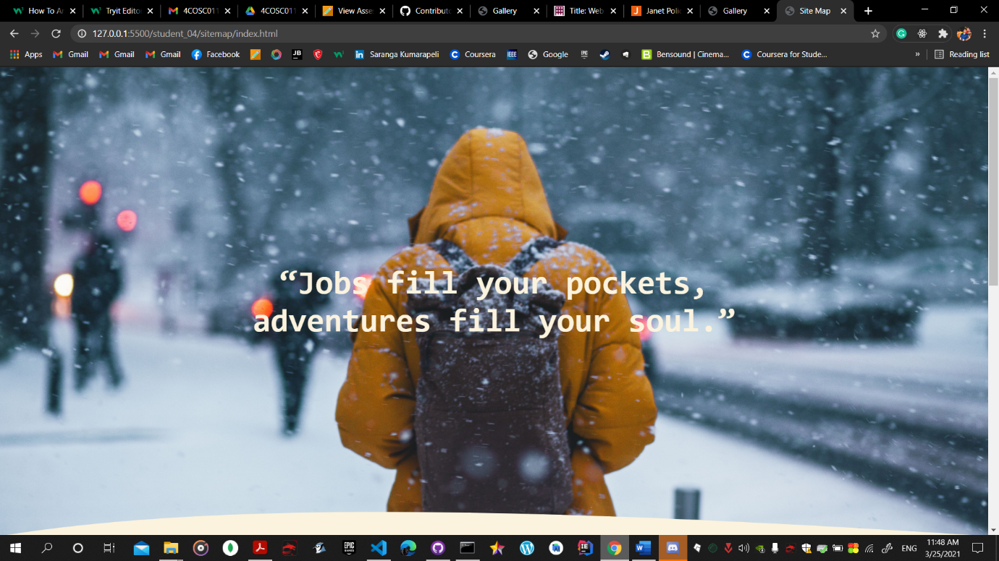

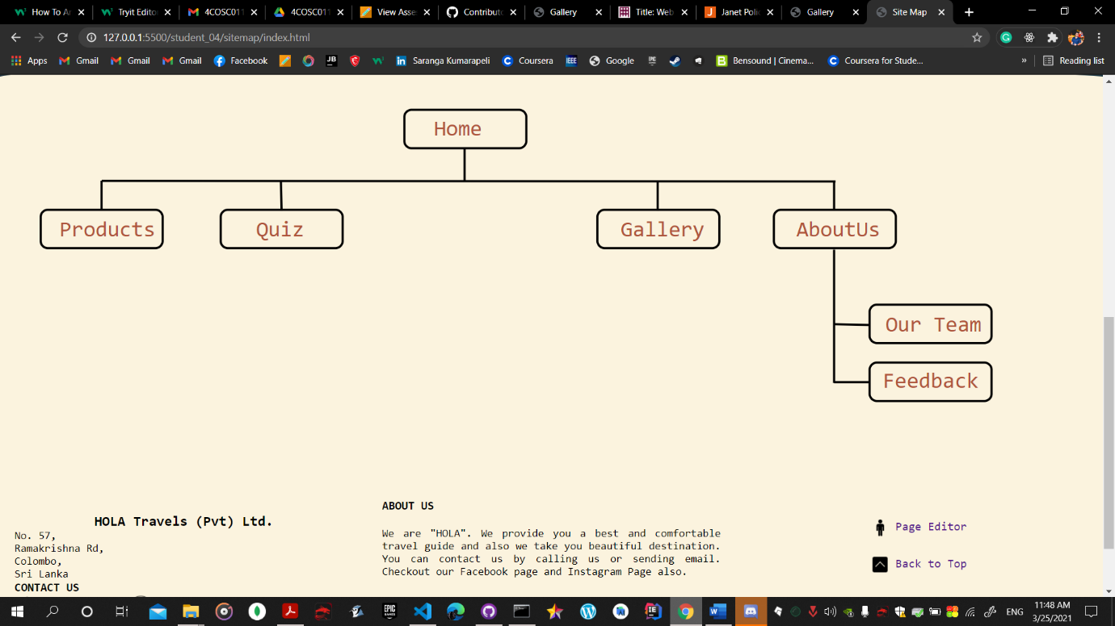

### gallery

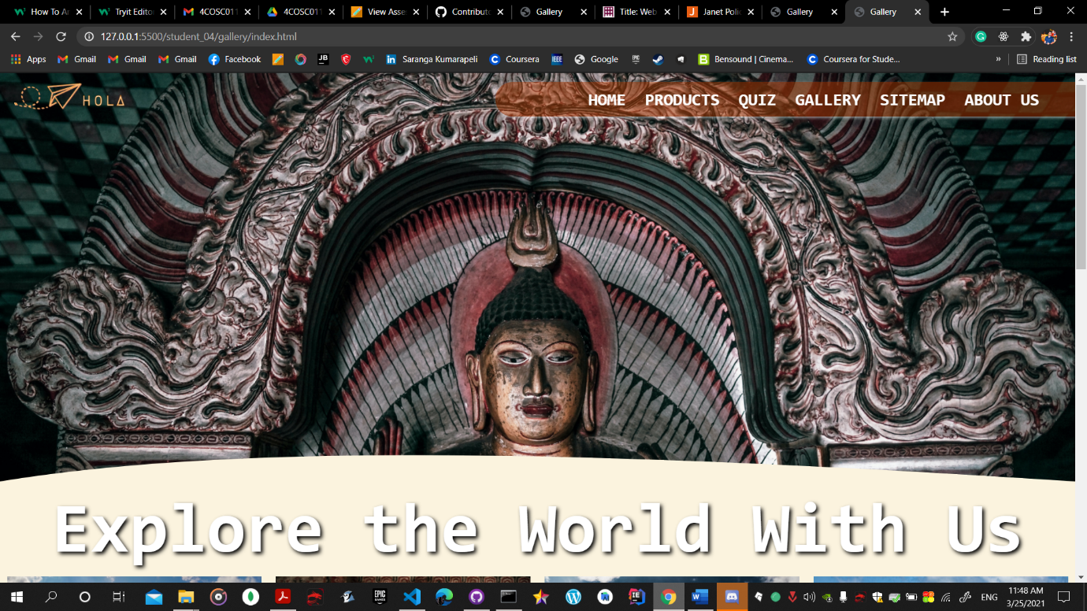

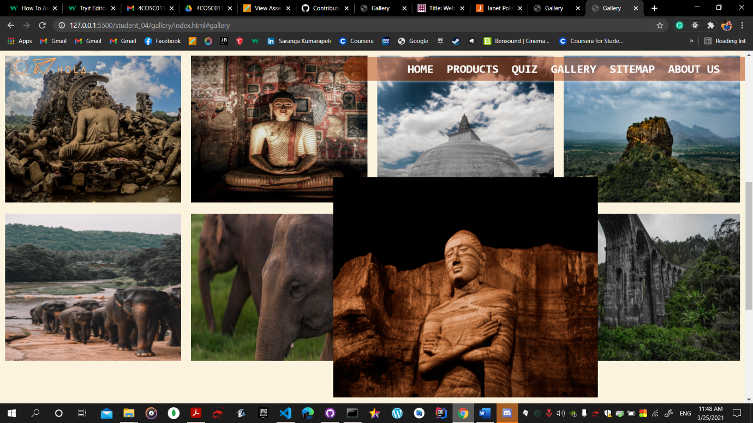

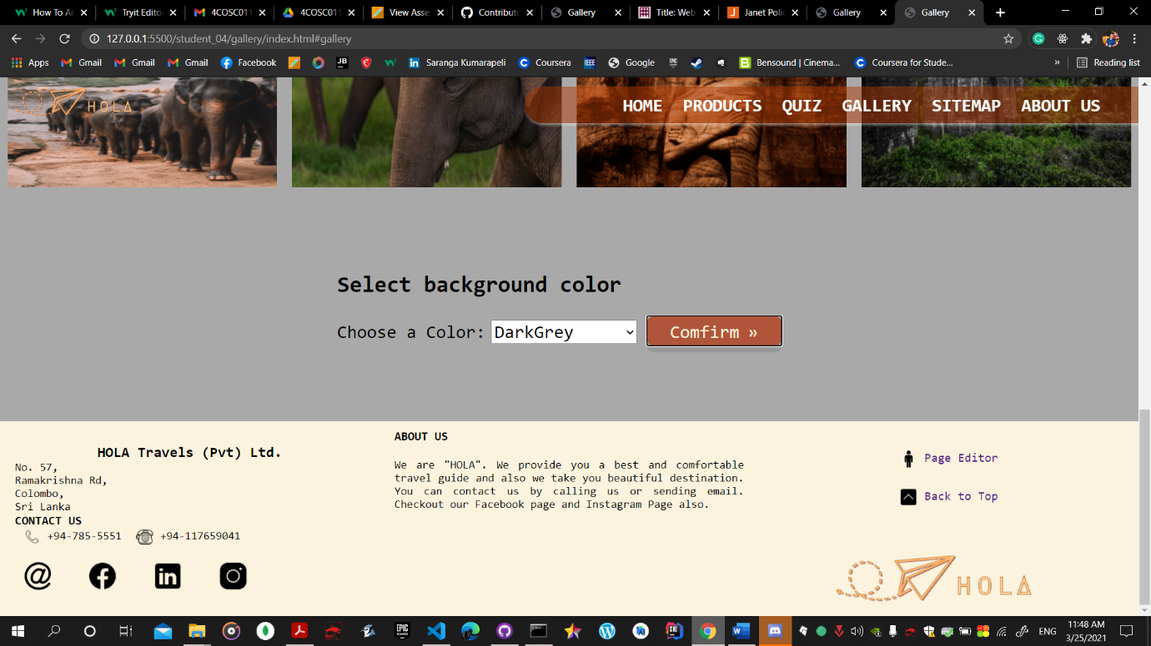

## Appendix C: Individual Statement

|  |  |  |  |
| --- | --- | --- | --- |
| Student Name: | K.A.D.S.T.Kumarapeli | Student Id: | 2019952 |
| State what tasks you carried out in the project. | | | |
| Logo design  Site Map  Gallery | | | |
| State what you enjoyed and did not enjoy about teamwork. | | | |
|  | | | |
| State what you learnt about teamwork. | | | |
| Time management  Knowledge sharing  Work as a team and help each other | | | |
| State what skills you gained/learnt from undertaking the project. | | | |
| Learnt javascript,css,html and collobrate with a team in git version control system.  Learnt how to configure wincsp server and deploy websites. | | | |
| State any strengths about yourself that emerged whilst undertaking the project. | | | |
|  | | | |
| State any weaknesses about yourself that emerged whilst undertaking the project. | | | |
|  | | | |
| State how you would do things better if you were to undertake the project again. | | | |
|  | | | |
| Additional general or project specific comments: | | | |
|  | | | |
| Student Signature: | Saranga | Date: | 24/03/2021 |